National
Ex Vivo Normothermic Perfusion Symposium

Friday 3rd July 2015

An NIHR Blood and Transplant Research Unit (BTRU) Event

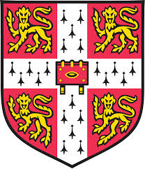
Meeting Report

Hosted by the University of Cambridge and the University of Newcastle

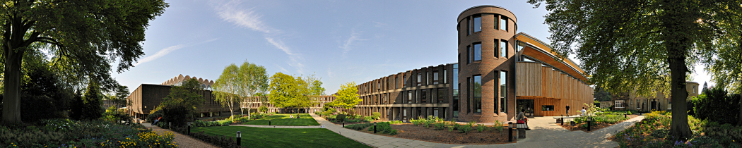

Fitzwilliam College, Storey’s Way, Cambridge, CB3 0DG
www.fitz.cam.ac.uk

Programme
08:15 | Coffee and Registration | Upper Hall 1
09:00 | Welcome & Introduction to the National EVNP Symposium Mr Kourosh Saeb-Parsy | Reddaway Room
09:10 | Introduction to the BTRU Prof Andrew Bradley & Prof Andy Fisher | Reddaway Room
09:20 | Kidney EVNP Chair: Prof Michael Nicholson & Prof Jordan Pober | Reddaway Room
09:20 | Dr Mike Murphy (Cambridge)  Why mitochondria are important to surgeons
09:40 | Prof Ina Jochmans (Leuven)  Kidney preservation - the European perspective
10:00 | Mr Gabi Oniscu (Edinburgh)  Ex vivo normothermic perfusion or normothermic regional perfusion?
10:20 | Dr Sarah Hosgood (Cambridge)  Renal Transplantation after EVNP
10:45 | Coffee Break | Upper Hall 1
11:00 | Lung EVNP Chair: Prof Andy Fisher & Dr James Fildes | Reddaway Room
11:00 | Prof Andy Fisher (Newcastle)  Clinical EVLP – how far have we come?
11:20 | Dr James Fildes (Manchester)  Leukocyte trafficking in experimental EVLP
11:40 | Mr Simon Becker (Hannover)  Evaluating acellular vs. cellular perfusate composition in experimental EVLP
12:00 | Mr Anders Andreasson (Newcastle)  Identifying predictive biomarkers in clinical EVLP
12:20 | Pancreas, Small Bowel and Limb EVNP Chair: Mr Kourosh Saeb-Parsy & Mr Christopher Callaghan | Reddaway Room
12:20 | Mr Adam Barlow (Cambridge)  Is EVNP a useful tool for viability assessment of the pancreas?
12:40 | Mr Mazin Hamed (Cambridge)  Small bowel EVNP as an experimental tool
12:50 | Mr Mo Akhavani (Royal Free)  Composite graft EVNP: Potential applications in limb transplantation and beyond
13:00 | Lunch | Upper Hall 1
14:00 | Heart EVNP Chair: Prof John Dark & Prof Stig Steen | Reddaway Room
14:00 | Dr Diana Garcia Saez (Harefield)  Perfusion for donor hearts outside of the standard acceptability criteria
14:20 | Mr Simon Messer (Papworth)  Perfusion strategies for successful clinical heart DCD transplantation
14:40 | Prof Stig Steen (Lund)  Expanding the Donor Heart Pool – Transport and Assessment
15:00 | Prof John Dark (Newcastle)  Overview – Dreams and Realities in Donor Heart perfusion
15:20 | Liver EVNP Chair: Prof Chris Watson & Prof Peter Friend | Reddaway Room
15:20 | Prof Peter Friend (Oxford)  Perfusion characteristics predicting viable livers: initial experience
15:40 | Mr Vasilis Kosmoliaptsis (Cambridge)  What’s the solution for perfusion?
16:00 | Mr David Nasralla (Oxford)  How to COPE with the challenges of conducting a multicentre EVNP trial
16:20 | Cross-Diaphragmatic Discussion PanelChair: Prof Andrew Bradley & Mr Kourosh Saeb-Parsy | Reddaway Room
All Session Chairs
Challenges and opportunities: Trial design and technology validation
16:55 | Summary and Close Mr Kourosh Saeb-Parsy | Reddaway Room

Meeting Report
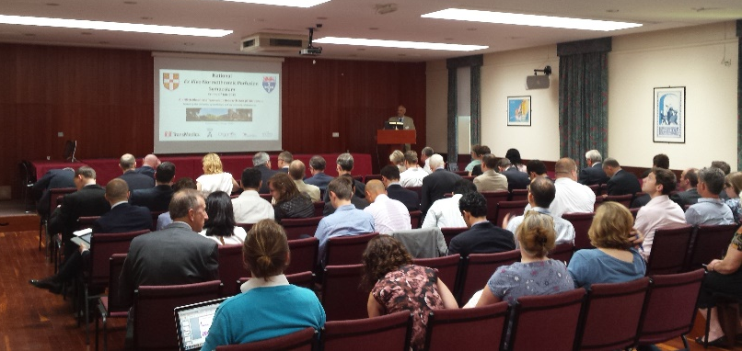
Introduction
The inaugural National EVNP Symposium was opened by Kourosh Saeb-Parsy (Cambridge) who welcomed the delegates and outlined the rationale for the establishment of this annual event. He highlighted the opportunity for cross-fertilisation and shared learning by research and clinical groups across abdominal and cardiothoracic specialities. Andrew Fisher (Newcastle) then gave a brief overview of the aims and objectives of the recently established NIHR Blood and Transplant Research Unit (BTRU), which consists of the Cambridge and Newcastle groups. He reiterated the desire of the BTRU to work closely with all UK groups and to share expertise and learning opportunities.
Kidney EVNP
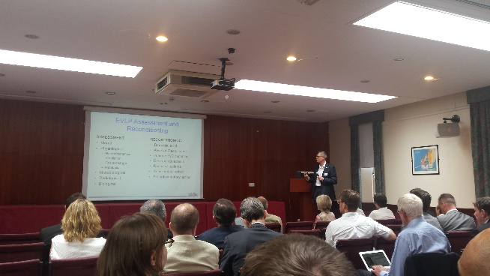
The Kidney EVNP session was chaired by Mike Nicholson (Cambridge) and Jordan Pober (Yale). Mike Murphy (Cambridge) opened the session with an overview of the critical role of mitochondria in transplant ischaemia-reperfusion injury. He used recent data from his group to illustrate how generation and the detrimental impact of mitochondrial reactive oxygen species (ROS) can be ameliorated using mitochondria-targeted therapeutics, including MitoQ and MitoSNO. He concluded by reviewing evidence that the metabolite succinate acts as the source of electrons for generation of ROS, and how prevention of succinate accumulation using malonate esters is protective. Ina Jochman (Leuven) then reviewed the current literature on cold machine perfusion for the preservation of kidneys prior to transplantation. The options available to transplant centres include cold static storage, continuous machine perfusion, or pre-implantation machine perfusion, while machine perfusion can be cold, sub-normothermic and normothermic, as well as oxygenated or non-oxygenated. It is also not clear which preservation methods are applicable to which (or all) donor cohorts (e.g., DCD or DBD, SCD or ECD). Similarly the necessary duration of the interventions for demonstration of efficacy is not known. There are a number of ongoing trials, but more studies are required to enable definitive conclusions about the efficacy of these technologies to be drawn. Gabi Oniscu (Edinburgh) then compared normothermic regional perfusion (NRP) with EVNP. The concepts and techniques were reviewed, together with outcomes from the few published studies, which are broadly comparable at this early stage. It may be desirable to combine NRP and EVNP for some donors or organs. NRP can potentially afford an opportunity to perform diagnostic tests on organs (including search for novel biomarkers) as well as therapeutic interventions. He concluded by reiterating that refinement of procedure, equipment and protocols, in the context of large clinical trials were required. Sarah Hosgood (Cambridge) concluded the kidney session by summarising the data from Leicester which demonstrated that one hour of EVNP of kidneys with leucocyte-depleted blood prior to transplantation was safe and likely results in a reduced rate of DGF. A trial of CSS v EVNP is due to start in autumn and continue for approximately 4 years. Data was also presented on the use of EVNP of kidneys to assess viability and quality of kidneys, including the development of a viability score based on EVNP of discarded human kidneys. The session concluded with an illustration of how EVNP can be used to deliver therapeutic interventions prior to transplantation, using the noble gas Argon as an example.
Lung EVNP
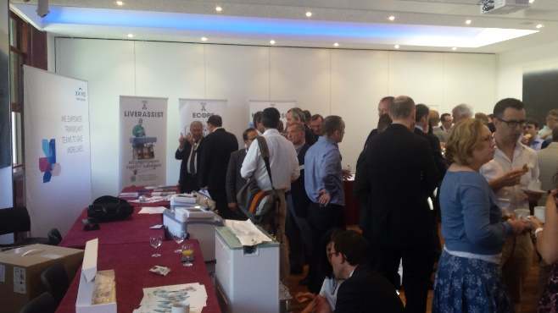
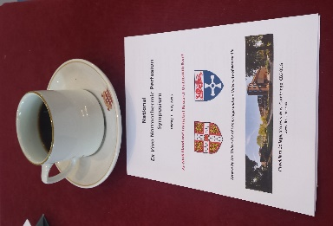
The Lung EVNP session was chaired by Andrew Fisher (Newcastle) and James Fildes (Manchester). Andrew Fisher (Newcastle) presented a summary of the current status of the lung transplant waiting lists, highlighting that lung utilisation from deceased donors remains low, particularly from DCD donors (<6%). Barriers to greater utilisation are organ function and viability, which can be addressed with ex vivo lung perfusion (EVLP). EVLP can be used for visual, physiological microbiological, radiological and biological assessment of lungs, as well as reconditioning (e.g., bronchial toilet, alveolar recruitment, improving VQ matching, reverse atelectasis, etc). Development has been fast, and there are many ongoing trials, including in the UK (e.g., INSPIRE and DEVELOP) with some early evidence that organ utilisation is increasing. James Fildes (Manchester) then presented a summary of the current understanding of leucocyte trafficking in experimental EVLP. EVLP affords an opportunity to manipulate the donor organ’s immunogenicity. Release of T cells, B cells and monocytes from the lungs on EVLP have been documented and characterised. In a porcine model of orthotopic pig lung transplantation, the inflammatory response was different in the EVLP vs control groups, with a significant decrease in donor derived cells in the recipient. Standard animals displayed histological evidence of rejection, but not in the EVLP group. Proteomic analysis showed that proteins involved in cell survival are upregulated in EVLP. Apoptosis is significantly decreased. In summary, EVLP represents a significant opportunity for immunomodulation and to reduce immunogenicity of transplanted lungs (and other organs). Simon Becker (Hannover) compared cellular and acellular perfusate composition for EVLP. In one study, lungs form pigs were stored in cold for 24 h followed by 12 h of EVLP with cellular or acellular perfusate. Macroscopic appearance was different, with some oedema in the acellular arm and red demarcation in the non-dependent areas of the lungs. Lung physiology (peak airway pressure, compliance) was similar in the two groups but there was some difference in pulmonary vasculature (PA pressure and PVR higher with cellular perfusate). There was no difference in oxygenation capacity. Glucose utilisation was similar in the two groups, as was lactate production. Electron microscopic analysis showed some difference. In summary, both cellular and acellular EVLP was possible after 24 hours of CIT. Anders Andreasson (Newcastle) concluded the session with a presentation on potential biomarkers in EVLP. A pilot study compared potential biomarkers in lungs (acellular protocol). Inflammatory cytokines, DAMPS and LDH levels were compared in the transplanted and non-transplanted groups. LDH, IL-8 and Syndacen-1 levels were lower in the transplanted lungs but there was no difference in IL-1β. A combination of cytokines together could predict whether the lungs are transplantable at 2 hours of EVNP with good sensitivity and specificity.
Pancreas, Small Bowel and Limb EVNP
The pancreas, small bowel and limb EVNP session was chaired by Kourosh Saeb-Parsy (Cambridge) and Chris Callaghan (Guy’s London). Adam Barlow (Cambridge) opened the session by describing the application of EVNP technology to pig and declined human pancreases. EVNP was able to partially discriminate between porcine models of mild, moderate and severe IRI, when examining parameters such as blood flow and amylase levels. A case series of 6 human pancreases assessed on EVNP were also presented, with the conclusion that much more work is required to refine pancreas EVNP. Mazin Hamed (Cambridge) then presented a proof-of-concept series of EVNP of 4 segments of pig small bowel. The segments of small bowel were all well perfused, exhibited peristalsis as well as absorptive and secretory function. Small bowel EVNP presents an opportunity to study intestinal IRI, physiology and immunogenicity in transplantation. Mo Akhavani (Royal Free) concluded the session by presenting the rationale for the utility of limb and composite graft EVNP as an experimental model in transplantation as well as in vascular and plastic surgery. He presented a case of pig forelimb EVNP as part of a collaboration between Cambridge and Royal Free.
Heart EVNP
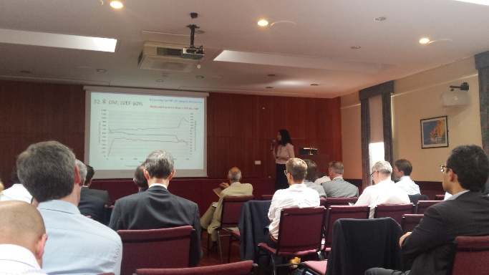
The Heart EVLP session was chaired by Joh Dark (Newcastle) and Stig Steen (Lund). Diana Garcia Saez (Harefield) opened the session with data from 56 EVNP hearts, all from DBD donors (33 outside standard criteria). 10 were not transplanted. The outcomes were generally positive, and the technology may allow expansion of the donor pool as well as reduction in cold ischaemic times. Simon Messer (Papworth) then presented the results of an analysis which predicted an additional 50 heart transplants could be performed per year from DCD donors in the UK. Papworth protocol, which included normothermic regional perfusion of the donor, followed by EVNP of the heart was described. The results of a series of 6 recent DCD transplants were presented, with good outcomes in all cases. Stig Steen (Lund) then presented data on a porcine model of brain stem death, followed by preservation of hearts for 24 hours. This included 15 minutes of perfusion with 60 minutes of non-perfusion at 8°C, using a mobile storage system. The technology allowed biventricular assessment of the hearts. The hearts, following orthotopic transplantation after 24 hours of storage, demonstrated remarkably good function. John Dark (Newcastle) subsequently chaired a discussion with all three presenters. He concluded that the presentations amounted to the vast majority of the world experience of clinical heart EVNP – UK is clearly leading the world in heart EVNP.
Liver EVNP
The Liver EVNP session was chaired by Peter Friend (Oxford) and Chris Watson (Cambridge). Peter Friend (Oxford) opened the session by summarising the available data on parameters for assessment of viability of livers during EVNP, including perfusion haemodynamics, metabolic function, synthetic function, cellular injury markers and inflammatory markers. Bile production and lactate levels are typically used as markers of liver function during EVNP, although the evidence for their validity is not entirely compelling and interpretation of levels can be difficult. Approximately 20 patients have been transplanted in one study in the UK, with primary function in all cases. Application of NMP to assessment of steatotic and DCD livers was discussed. Vasilis Kosmoliaptsis (Cambridge) subsequently summarised some of the variables in models of liver EVNP, including infusions and additions, composition (cellular or acellular), pressures, leukocyte filters, temperature, gas and electrolyte composition, infusions (e.g., PN), drugs (e.g., vasodilators, insulin, etc). The validity and rationale for the choice of these parameters requires more detailed study. David Nasralla (Oxford) concluded the session by discussing the challenges and pitfalls of running a multi-centre liver EVNP trial. The aim of the COPE trial is to recruit 260 patients, randomised to EVNP or CSS. Challenges related to the use and transport of the device, benchwork preparation of the liver, theatre logistics and clinical decision making with regards to suitability of the organs for transplantation.
Summary
The meeting was concluded by Andrew Bradley (Cambridge) and Kourosh Saeb-Parsy (Cambridge) who chaired a ‘cross-diaphragmatic’ discussion panel involving all symposium session chairs. The need for large well designed studies was re-iterated, acknowledging the multitude of organ preservation and resuscitation options and technologies that are available. It was agreed that the symposium had been of immense education value and the next meeting was confirmed to be on Friday 1st July 2016 in Cambridge.

2016 National Ex Vivo Normothermic Perfusion Meeting:

Friday 1st July 2016, Fitzwilliam College, Cambridge

Contact:
Kourosh Saeb-Parsy (ks10014@cam.ac.uk)

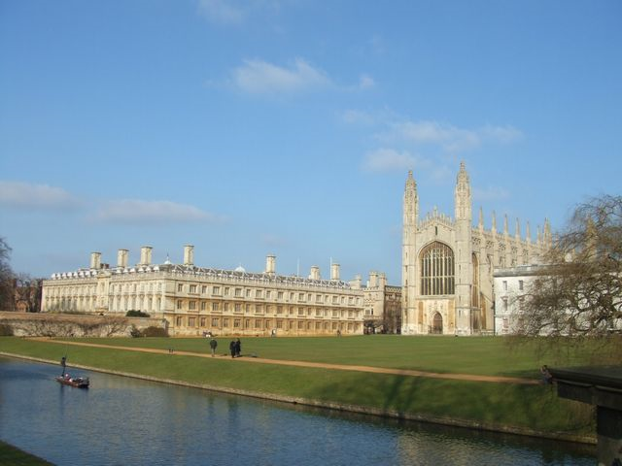

2015 Symposium Sponsors

